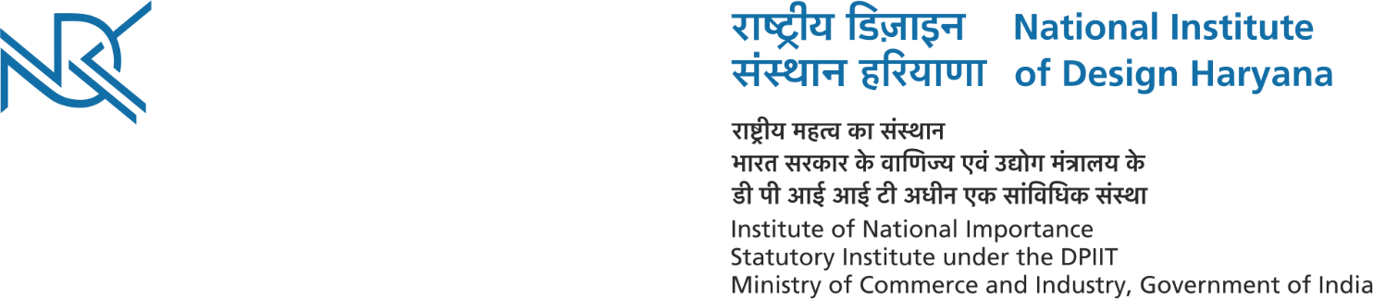
R.No. NIDH/E&M/2021/107 Dated: 19th March, 2021

CORRIGENDUM

The last date of submission of Tender for providing and placing site/factory constructed/fabricated fully customized tables at NID Haryana campus has been extended up to 25.03.2021 till 05.00 pm.

This issues with the approval of the Competent Authority.

Chief Administrative Officer

